Build One Play Testing: Variables

Game: Fling it Wing it

* Two player physics game.
* Targeted age 7-10 but opened to all age groups

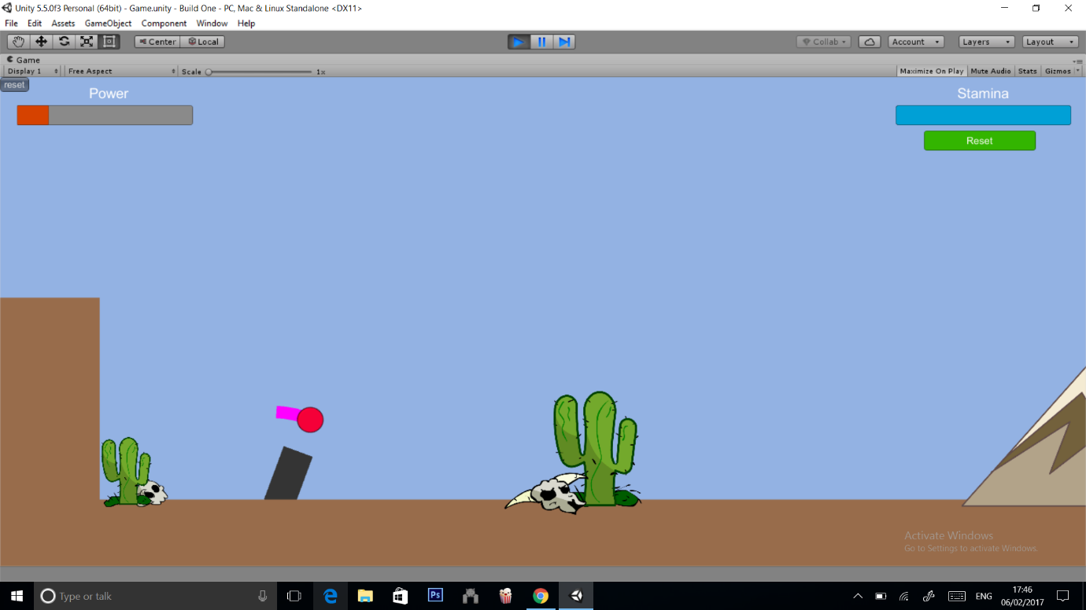Screenshots of current build

Figure : Player aiming

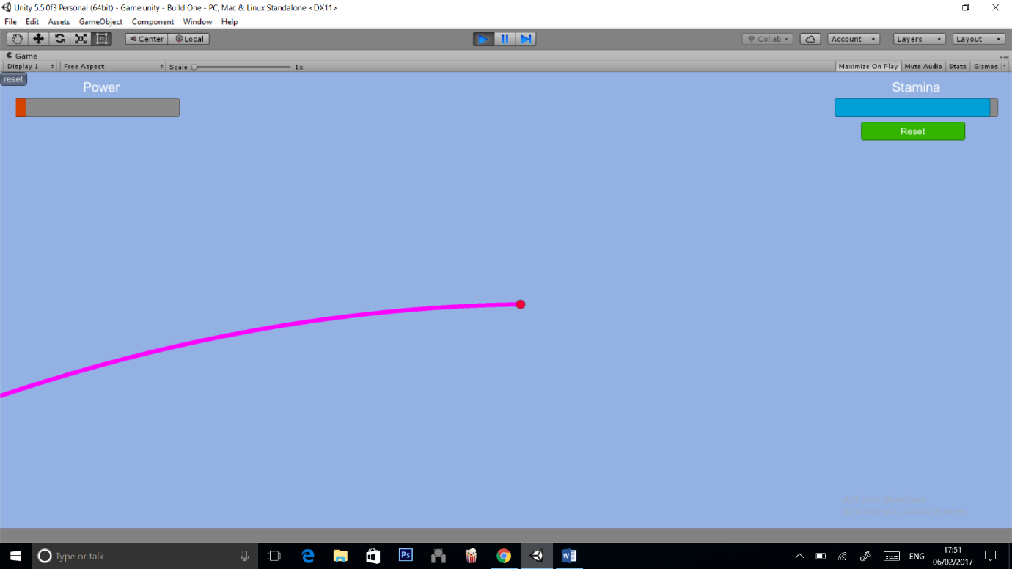

Figure : player ball in the air

Player Details

* Male
* Aged 20

When asked about variables of the game, the player explained:

* The force applied to the ball upon launch is too much.
* The speed of the ball is “too slow”.

The player also went on to explain:

* When in the air the static blue screen makes it hard to gauge how far or fast the ball is traveling.
* To combat this the player had suggested clouds or birds into the sky. (A sort of feedback loop to allow players gauge their distance and speed)
* The player explained the gameplay is “slow” ad would benefit from being paced faster.